**Infrastructure as Code with Terraform and Ansible**

**Commands**:

1. md terraform
2. cd terraform
3. foreach ($file in @('main.tf','terraform.tfvars','variables.tf')) {

$uri = "https://raw.githubusercontent.com/NoBSDevOps/BookResources/master/Part-II-Project/Virtual-Machines/Terraform-VMs/VMs/$file"

Invoke-WebRequest -Uri $uri -OutFile $file

}

1. terraform init
2. terraform plan
3. curl <http://ifconfig.me> (on cloud shell)
4. curl <http://ifconfig.me> (on local machine - powershell)
5. terraform apply -var="location=eastus" -var="resource_group=monolithRG" -var="cloud_shell_source=13.73.177.118" -var="domain_name_prefix=cloud-1" -var="management_ip=141.2.185.16" -auto-approve
6. cd ..
7. mkdir ansibleConfigs
8. cd ansibleConfigs
9. foreach ($file in @('hosts','iis.yml')) {

$uri = " https://raw.githubusercontent.com/NoBSDevOps/BookResources/master/Part-II-Project/Virtual-Machines/Ansible-Configuration/$file"

Invoke-WebRequest -Uri $uri -OutFile $file }

1. code .
2. Change the IPs to the VM IPs
3. 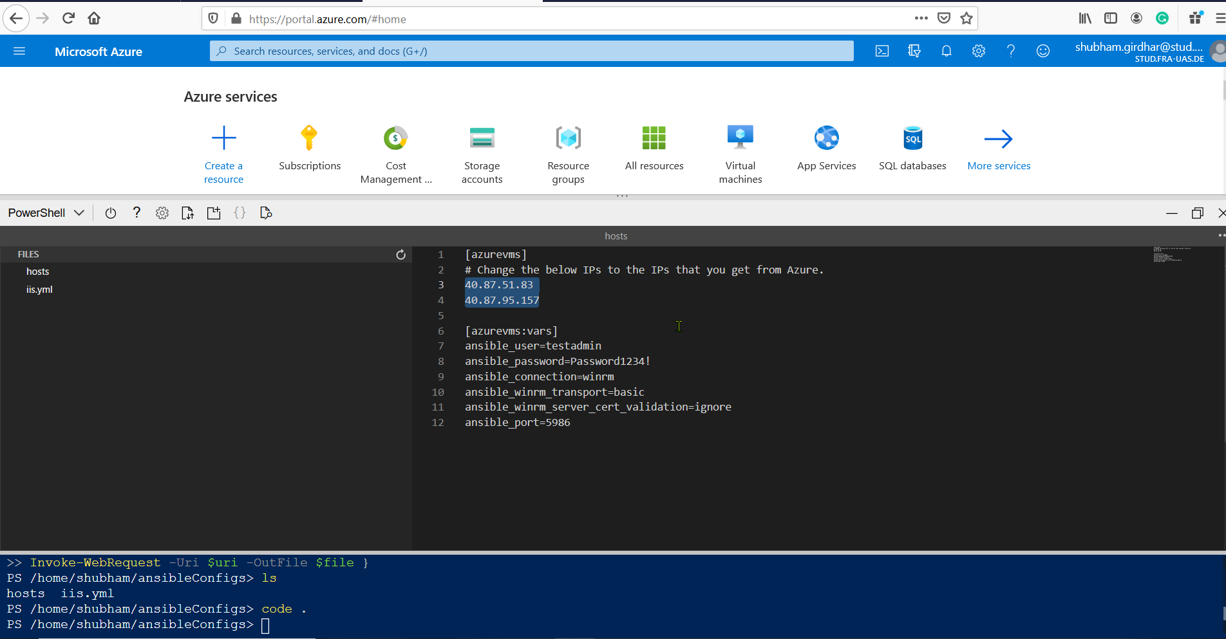
4. ansible-playbook iis.yml -i hosts
5. terraform destroy -auto-approve